**Eisenhower and the Cold War**

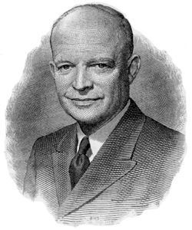

**(Foreign Policy under Eisenhower)**

**Dulles' Diplomacy**

Rollback - "liberating captive nations" of Eastern Europe and encouraging the Nationalist government of Taiwan to assert itself against "Red" (Communist) -"brinkmanship." I

**Massive retaliation.**

Dulles advocated greater reliance on nuclear weapons and air power and spending less on conventional forces of the army and navy.

such weapons could not prevent small "brushfire" wars from breaking out in the developing nations of Southeast Asia, Africa, and the Middle East.

**Unrest in the Third World**

collapse of colonial empires after World War II may have been the single most important development of the postwar era. Between 1947 and 1962, dozens of colonies in Asia and Africa gained their independence. In Asia, India and Pakistan became new nations in 1947 and the Dutch East Indies became the independent country of Indonesia in 1949. In Africa, Ghana threw off British colonial rule in 1957, and a host of other nations followed. These new, Third World countries (in contrast to the industrial nations of the Western bloc and the Communist bloc) often lacked stable political and economic institutions. Their need for foreign aid from either the United States or the Soviet Union often made them into pawns of the Cold War.

**Covert Action**

**Iran**

In 1953 the CIA played a major role in helping to overthrow a government in Iran that had tried to nationalize the holding of foreign oil companies. The overthrow of the elected government allowed for the return of Reza Pahlavi as shah (monarch) of Iran. The shah in return provided the West with favorable oil prices and made enormous purchases of American arms.

**Guatamela**

In1954, the CIA overthrew a leftist government that threatened American business interests. U.S. opposition to communism seemed to drive Washington to support corrupt and often ruthless dictators, especially in Latin America. This tendency produced growing anti-American feeling, which

became manifest when angry crowds in Venezuela attacked Vice President Nixon's motorcade during his goodwill tour of South America in 1958.

**Asia**

**Korean armistice.**

diplomacy, the threat of nuclear war, and the sudden death of Joseph Stalin in March 1953 finally moved China and North Korea to agree to an armistice and an exchange of prisoners in July 1953. The fighting stopped and most (but not all) U.S. troops were withdrawn. Korea would remain divided near the 38th parallel, and despite years of futile negotiations, no peace treaty was ever concluded between North Korea and South Korea.

**Fall of Indochina.**

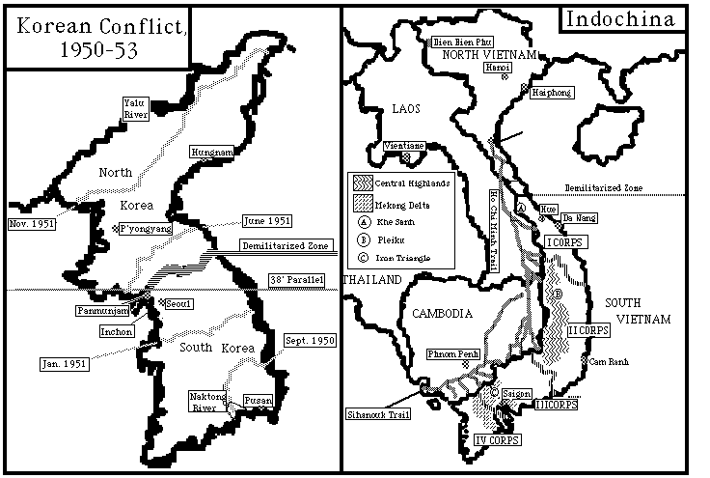France After lost their Southeast Asian colony of Indochina to Japan in WW II – the French made the mistake of trying to retake it. Wanting independence, native Vietnamese and Cambodians resisted. French imperialism had the effect of increasing support for nationalist and Communist leader Ho Chi Minh. By 1950, the anticolonial war in Indochina became part of the Cold War rivalry between Communist and anticommunist powers. Truman's government started to give U.S. military aid to the French, while China and the Soviet Union aided the Viet Minh guerrillas led by **Ho Chi Minh.** In 1954, a large French army at **Dien Bien Phu** was trapped and forced to surrender.

Geneva Conference of 1954, France agreed to give up Indochina, which was divided into the independent nations of Cambodia, Laos, and Vietnam.

**Division of Vietnam.**

By the terms of the **Geneva Conference**, Vietnam was to be temporarily divided at the **17th parallel** until a **general election** could be held. The new nation remained divided, however, as two hostile governments took power on either side of the line. In North Vietnam, Ho Chi Minh established a Communist dictatorship. In South Vietnam, a government emerged under **Ngo Dinh**

**Diem**, whose support came largely from anticommunist, Catholic, and urban Vietnamese, many of whom

had fled from Communist rule in the North. The general election to unite Vietnam was never held, largely because South Vietnam's government feared that the Communists would win. From 1955 to 1961, the United States gave over $1 billion in economic and military aid to South Vietnam in an effort to build a stable, anticommunist state.

***domino theory*** (later to become famous), if South Vietnam fell under Communist control, one nation after another in Southeast Asia would also fall, until Australia and New Zealand were in dire danger.

**SEATO.**

To prevent the "fall to communism of South Vietnam, Laos, and Cambodia, Dulles put together a regional defense pact called the Southeast Asia Treaty Organization (SEATO). Agreeing to defend one another in case of an attack within the region, eight nations signed the pact in 1954 (the United States, Great Britain, France, Australia, New Zealand, the Philippines, Thailand, and Pakistan).

**The Middle East**

United States had the difficult balancing act of maintaining friendly ties with the oil-rich Arab states while at the same time supporting the new state of Israel. The latter nation was created in 1948 under U.N. auspices, after a civil war in the British mandate territory of Palestine left the land divided between the Israelis and the Palestinians. Israel's neighbors, including Egypt, had fought unsuccessfully to prevent the Jewish state from being formed.

**Suez Crisis.**

General Gamal Nasser, Egypt asked the United States for funds to build the ambitious Aswan Dam project on the Nile River. The United States refused, in part because Egypt threatened Israel's security. Nasser turned to the Soviet Union to help build the dam. The Soviets agreed to provide limited financing for the project. Seeking another source of funds, Nasser precipitated an international crisis in July 1956 by seizing and nationalizing the British and French-owned Suez Canal. Loss of the canal threatened Western Europe's supply line to Middle Eastern oil. In response to this threat, Britain, France, and Israel carried out a surprise attack against Egypt and retook the canal.

A furious Eisenhower, who had been kept in the dark by his old allies the British and French, sponsored a U.N. resolution condemning the invasion of Egypt. Under pressure from the United Sates and world public opinion, the invading forces withdrew. After the Suez crisis, Britain and France would never again play the role of major powers in world affairs.

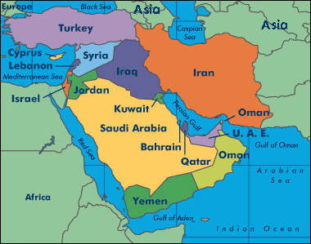

**Eisenhower Doctrine.**

the United States in 1957 pledged economic and military aid to any Middle Eastern country threatened by communism

applied in Lebanon in 1958 by sending 14,000 marines to that country to prevent the outbreak of a civil war between Christians and Muslims.

**OPEC and oil.**

the Arab nations of Saudi Arabia, Kuwait, Iraq, and Iran joined Venezuela to form the Organization of Petroleum Exporting Countries (**OPEC**). Oil was shaping up to be a critical foreign policy issue.

**U.S. - Soviet Relations**

In terms of U.S. security, nothing was more crucial than U.S. diplomatic relations with its chief political and military rival, the Soviet Union. Throughout Eisenhower's presidency, the relations between the two superpowers fluctuated regularly from periods of relative calm to periods of extreme tension.

**Hungarian Revolt.**

The relaxation in the Cold War encouraged workers in East Germany and Poland to demand reforms from the Communist governments of these countries. In October 1956 a popular uprising in Hungary actually succeeded in overthrowing a government backed by Moscow. It was replaced briefly by more liberal leaders who wanted to pull Hungary out of the Warsaw Pact, the Communist security organization. This was too much for the Kremlin, and Khruschev sent in Soviet tanks to crush the freedom fighters and restore control over Hungary. The United States took no action in the crisis. Eisenhower feared that if he sent troops to aid the Hungarians, it would touch off a world war in Europe. In effect, by allowing Soviet tanks to roll into Hungary, the United States gave de facto recognition to the Soviet sphere of influence in Eastern Europe and ended Dulles' talk of "liberating" this region. Soviet suppression of the Hungarian revolt also ended the first thaw in the Cold War.

***Sputnik* shock.**

In 1957, the Soviet Union shocked the United States and surprised the world by launching the first satellites, *Sputnik I* and *Sputnik II*, into orbit around the earth. Suddenly, the technological leadership of the United States was open to question.

5

**NASA** - to direct the U.S. efforts to build missiles and explore outer space. Billions were appropriated to compete with the Russians in the space race.

Fears of nuclear war were intensified by *Sputnik*, since the missiles that launched the satellites could also deliver thermonuclear warheads anywhere in the world in minutes, and there was no defense against them.

**U-2 incident.**

the Russians shot down a high-altitude U.S. spy plane - the U-2 - over the Soviet Union. Eisenhower took full responsibility for the flights - *after* they were exposed by the U-2 incident - but his honesty proved a diplomatic mistake. Khruschev had little choice but to denounce Eisenhower and call off the Paris summit.

**[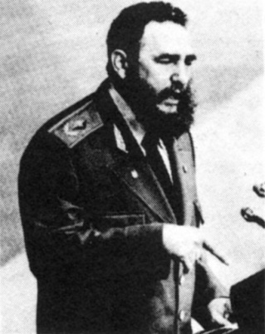](http://www.law.harvard.edu/studorgs/forum/castro.jpg)Communism in Cuba**

A bearded revolutionary, ***Fidel Castro***, overthrew the Cuban dictator Fulgencio Batista in 1959. Turned Cuba into a totalitarian state

Eisenhower authorized the CIA to train anticommunist Cuban exiles to retake their island, but the decision to go ahead with the scheme was left up to the new president, Kennedy.