Muckrakers
- _______________________an individual who seeks to expose or reveal corruption of businesses or government to the public.
  - Urban Life & ________________________
  - Anti-Big Business
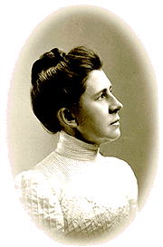
  - _____________________________

- Ida Tarbell
  - Wrote ___________________ attacking Rockefeller’s Standard Oil Company
  - Changed forever the role of ____________________________
- Negative exposé of the business practices of Rockefeller and trusts.

- Lewis Hine
- Photo journalist who sought to improve _______________________________

- Thomas Nast
- Father of American ________________________
- Exposed ________________ and Tammany Hall’s political corruption
- “________________________” leagues were formed to replace corrupt leaders
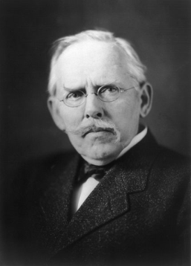
Jacob Riis
- Pioneer of ____________________
- Exposed corrupt living arrangements in the tenements of NYC – “_______________________________”

Upton Sinclair
- Responsible for criticizing the __________________________________
- Wrote the ____________________ which highlighted meat industry practices through a fiction story

