McCarthyism: The hysteria of the Second Red Scare

Search for Internal Security
- ________________________________ to the wishes of the country a must for the government and society for many Americans.
  - Were highly _________________ of anything or anyone considered different.
  - Regarded people with different opinions as a ___________________________
  - Only way to measure loyalty was the intensity and consistency of a person’s ____________________________.
  - Result: a ______________________ to root out suspected Communists from every aspect of society.

Truman’s Foreign Policy
- Truman’s foreign policy plays on these sentiments.
  - Reinforced the traditional fears of the _________________________________.
  - Uncovered spy rings in Canada, Britain, and other nations confirm suspicions about the Soviet Union’s intent: total world domination through the _____________________ of existing governments.

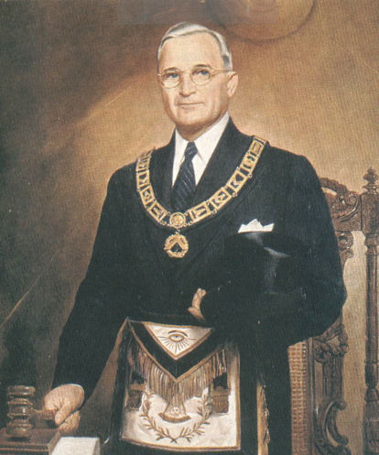
- Cabinet members make speeches that state that communists were everywhere in America and could be anybody.
  - Basic message: _______________________________.
  - Wanted people to turn in people they suspected of associating or sympathizing with communism.
  - Special targets placed on _____________________________, __________________________, publishing companies, and editorial staffs.

Pre-McCarthy McCarthyism
_______________________________________________, Mar 1947
- Full-scale “_______________________________________” of all present and prospective __________________________________________________.
- No source of information, no matter how inaccurate or questionable, was to be ignored.
- Impact of the LRB.
  - Business organizations, __________________________, and the government would use the list to fire or deny hiring employees.
  - Laid the ground work for the new Red Scare and the witch hunts of ___________________ and Senator Joseph ___________________________________.

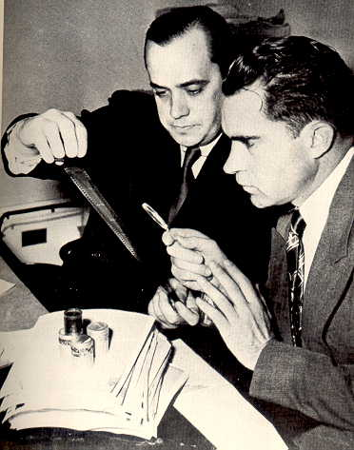
HUAC
(_________________________________________________________)
Origins.
- Originally founded in 1938 during the New Deal as a temporary investigations unit.
- Fell out of favor in World War II, but was revived by newly-elected Congressman ____________________________________ of CA.
- Would serve to destroy the lives of __________________________ and _________________________________________ of key individual politicians.

Purpose:_____________________________________________________________________
________________________________________________________________________________

How HUAC functioned.
______________________________________________________________.
- As a result, many would tell lies in order to save their own skin.
- Refusal to answer questions or cooperate was similar to an ___________________________________________.

The _____________________ of __________________________, 1947.
- Wanted to “expose those elements that are insidiously trying to…poison the minds of your children, distort the history of our country, and discredit Christianity.”
- Was a failure in its attempt to prove Communist influence in the film industry.
What it did do:
  - Frightened _______________________________________________ executives into doing a housecleaning.
  - ________________________actors, actresses, writers, and directors who were suspected of having Communist sympathies.
  - Forced the movie, television, radio, comic book, and newspaper industries to ____________________________, many of which would last into the Eighties.

___________________________________________.
- Was an official in the _____________________________ during the New Deal and the early years of World War II.
- President of the Carnegie Endowment for International Peace, one of the world’s richest philanthropic institute, since 1947.
- Accused of being a _____________________________.
- Hiss denies the accusations and demands to have a hearing by HUAC.
- Hiss is charged with being involved in a Soviet spy ring.and passing classified government documents to the Soviets.
- Hiss denies involvement.
- HUAC does not buy it, sentences Hiss to __________years in prison and a $_________________ fine for perjury.

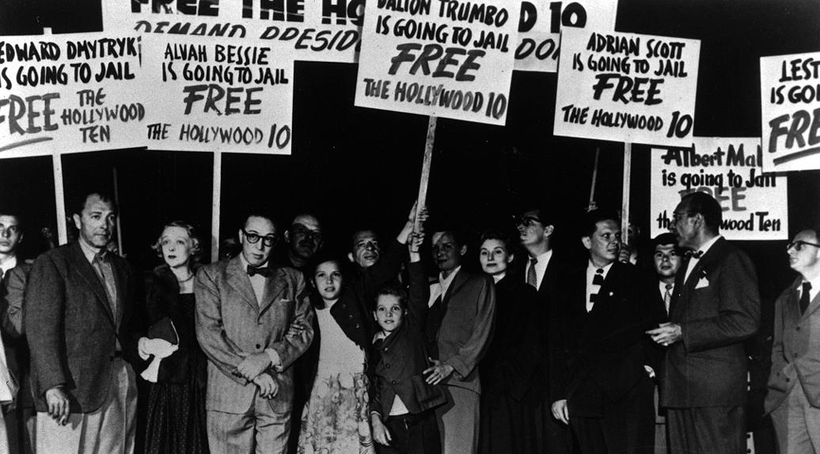

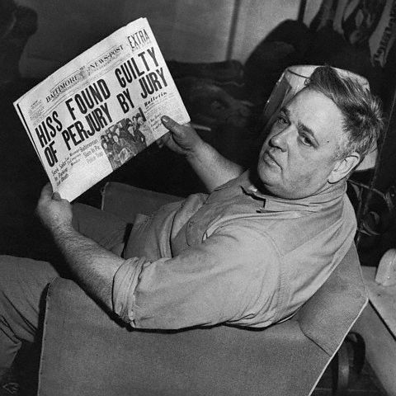
Impact.
- Would further uphold the belief that privileged, high-positioned individuals had betrayed the country.
- HUAC would gain support from established Americas, as well as ___________, Italian, and _____________ immigrants in the Midwest.

Senator: Joesph McCarthy

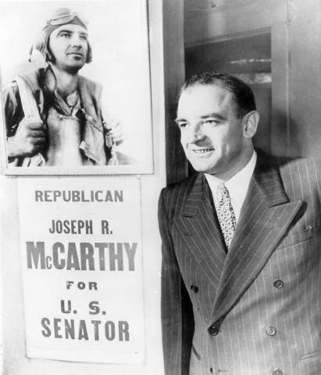
McCarthyism Defined:

________________________________, February 9, 1950.
- Declared that the United States had emerged from World War II as the strongest nation in the world.
- Believed that it had been weakened in recent years “because of the ____________________________ actions of those who have been treated so well by this nation.”
- None were worse than “those bright young men” in the __________________________ “born silver spoons in their mouths.”
- Blames the privileged, educated ______________ brought in by _______________.
- “I have in my hand the names of __________ men that were known to the Secretary of State as being members of the Communist party and who nevertheless are still working and shaping the policy of the State Department.”
- Never substantiated a ____________________, but increased
the accusations.

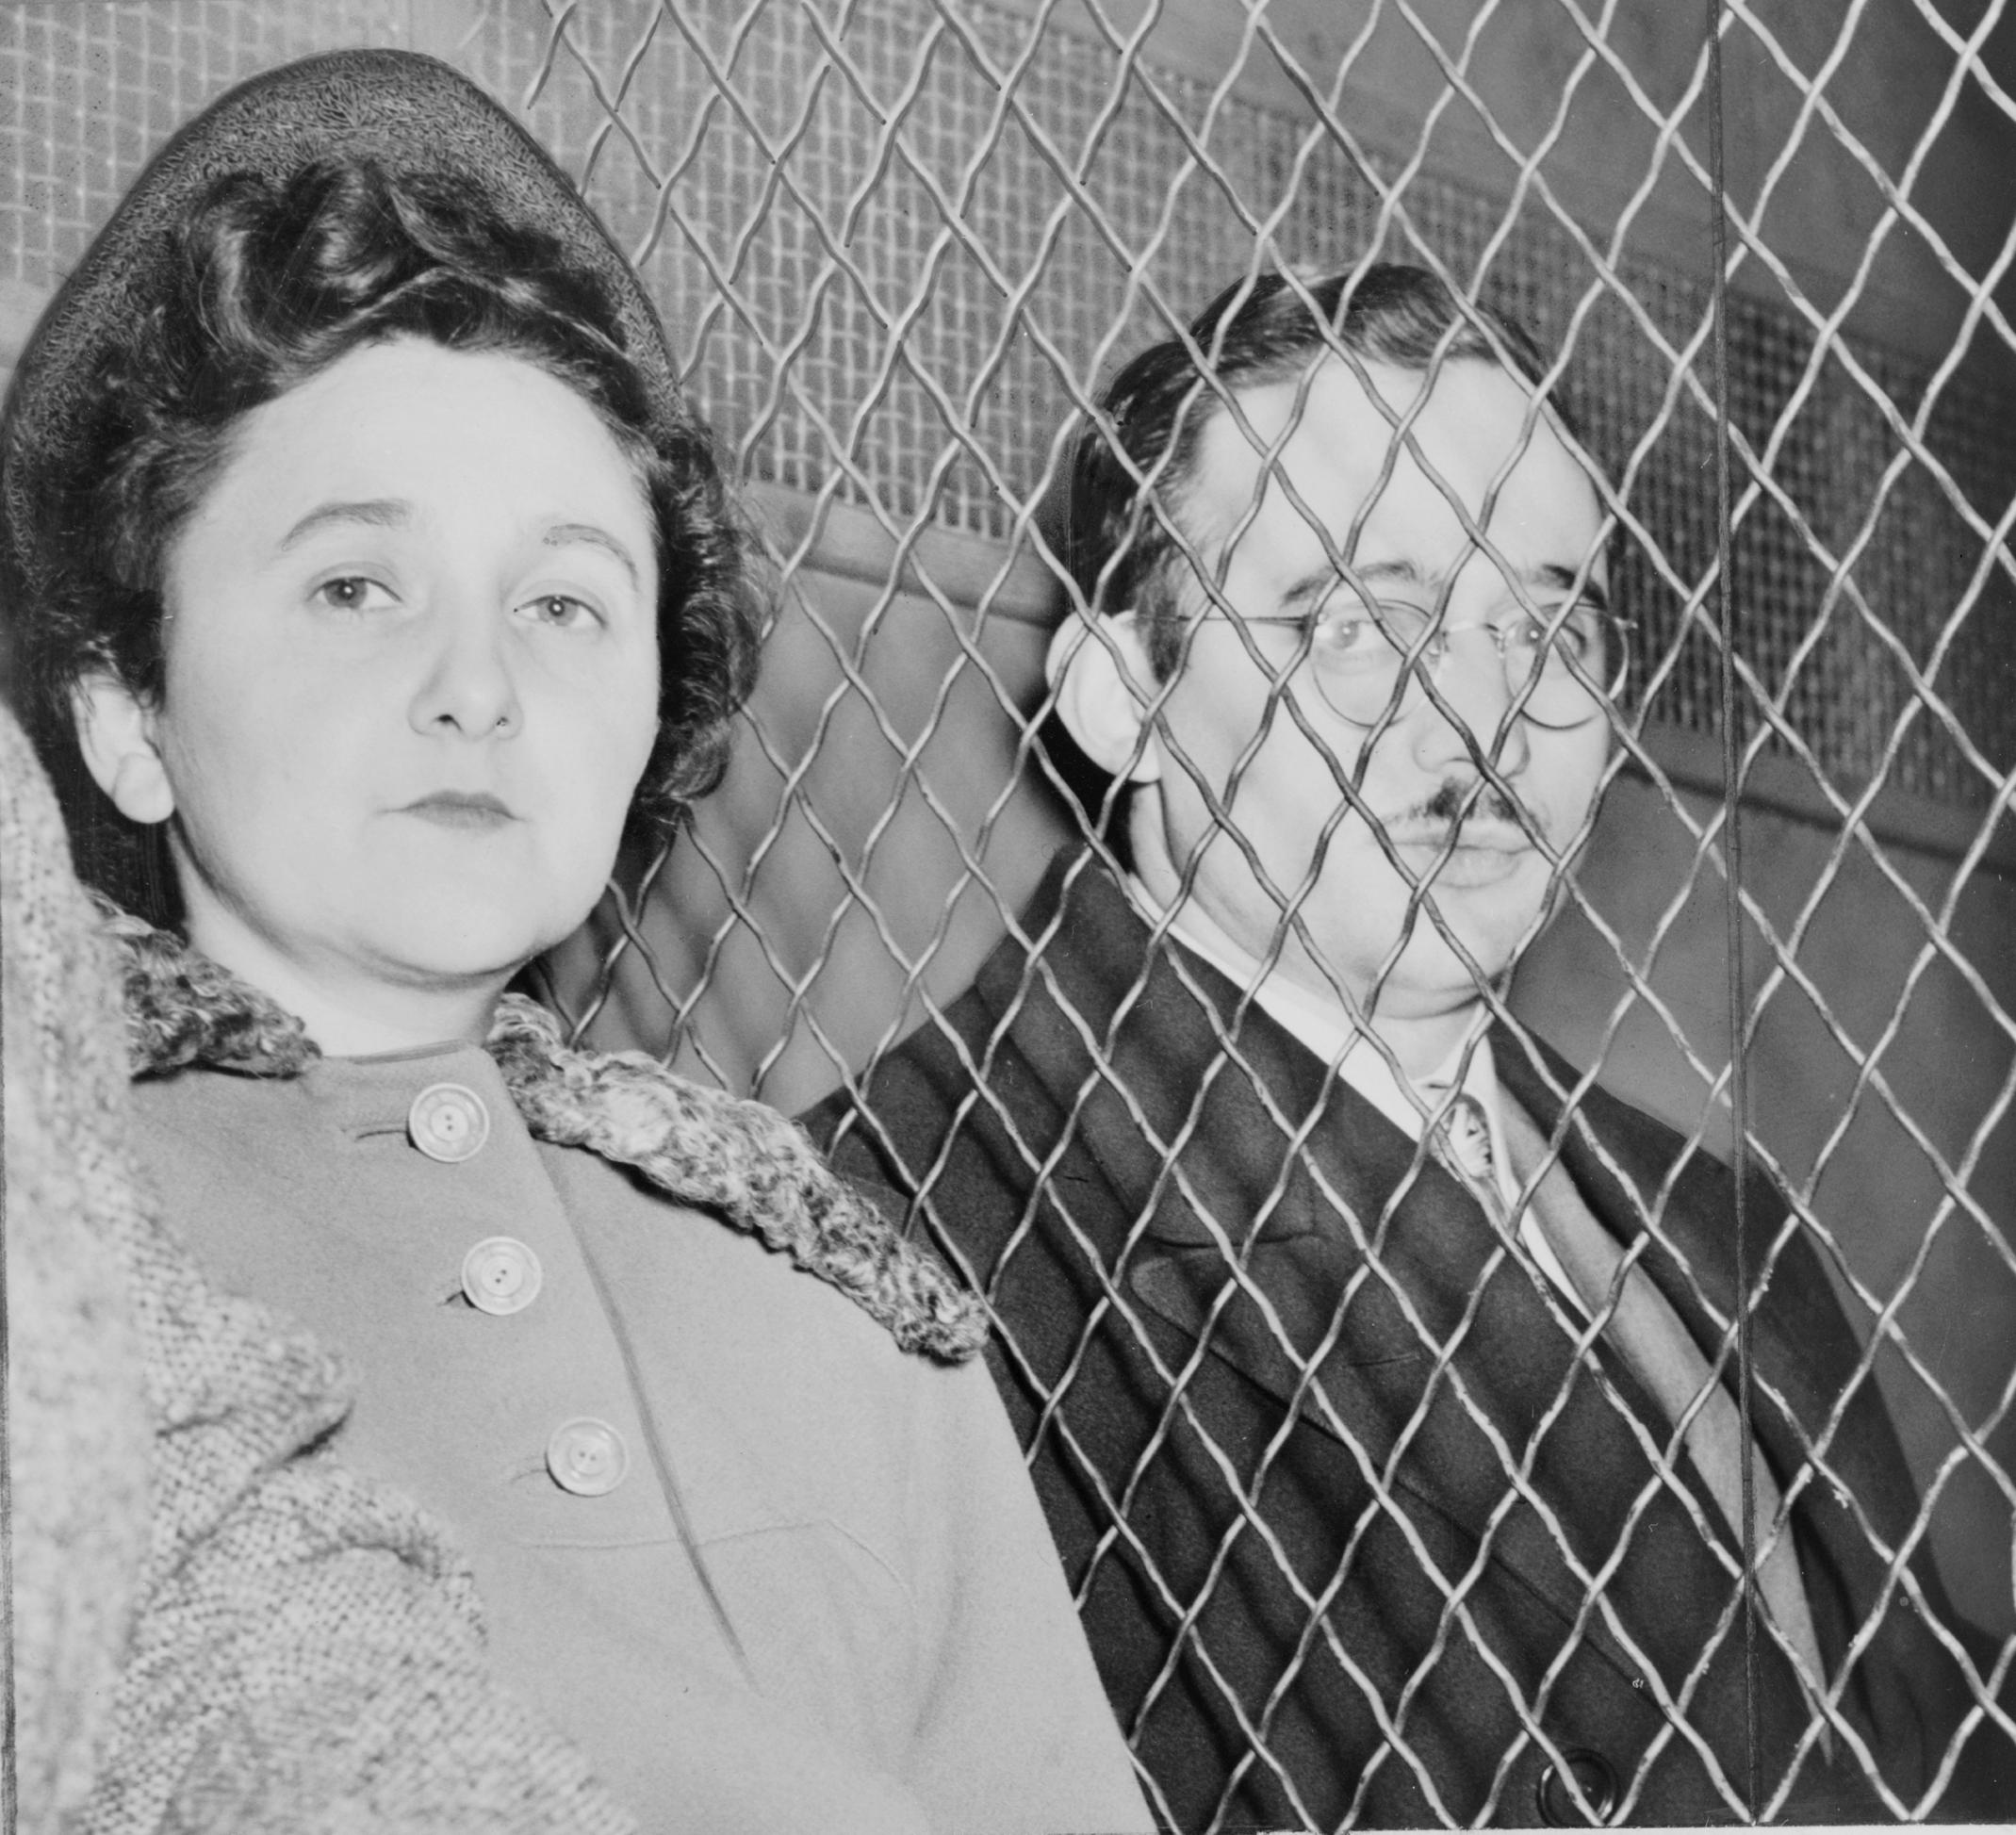
McCarthy: Stroke of Luck--______________
Ethel and Julius _________________________.
- Charged with passing atomic secrets and speeding up Russian success with the _________________________.
- Judge declared the crime “_____________________________.”
Rosenbergs _________________________________ in 1953

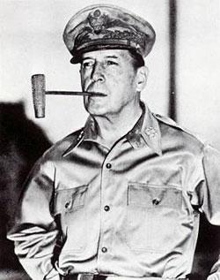
McCarthy: Picks Up Steam
- McCarthy supports _________________________ following his dismissal by Truman.
- Attacks General Marshall and General Eisenhower, accusing them of “______________” on Communists in the military.
- Some Americans felt McCarthy had gone too
far, but money kept pouring into McCarthy’s
election coffers.

McCarran Acts, 1952
- _____________________________________________________ Act.
- Made it unlawful to conspire to establish a _____________________
____________________________
- All “_________________________” and “communist front” organizations were assumed to be such conspiracies.
____________________________ all members and meeting notes with the Attorney General.
  - Gave the president the power to _________________________________________ that would “________________________” engage in acts of ________________________________.

Truman’s response.
- ____________________ the bill, calling it “the greatest danger to freedom of speech, press, and assembly since the alien and sedition acts of 1798.”
- Believed it was actually a step towards the _______________________ it was meant to combat.
- Congress ________________ the veto.

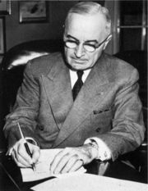

Decline of McCarthyism, 1953-55
_________________________________________.
- McCarthy accuses the U.S. Army of “________________” Communists in the U.S.
- Also questions the loyalty and integrity of several top
generals.
- First time many Americans actually witnessed McCarthy’s wild accusations.
- __________________ to the viewing audience, Army
officials, and his fellow Senators.
  - Result: Senate officially condemns McCarthy for “______________________________________________________________________________________________________________.”
  - McCarthy’s power would decline until his death in 1957 from ____________________________,

