India

Caste system – social groups into which people are born and cannot change out of
  - The Indian caste system functioned, political institution by enforcing rules about social behavior.
[Helped Aryans gain power over other groups]
[Reinforced through Hinduism and still present in Indian culture]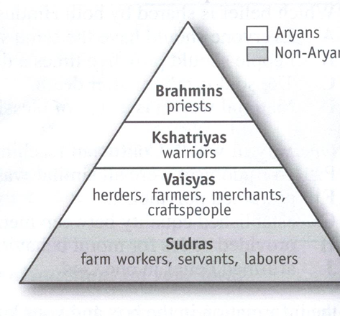

Indian Dynasties
- Mauryan Dynasty
  - Aryan influenced the development of Hinduism and Buddhism
  - Founded by Chandragupta Maurya (324 – 301 BC)
  - King set up his government with governors and secret police

- Key features
  - Well organized and highly centralized empire
  - Empire divided into provinces rules by governors
  - Rule was reinforced by army and spies

- Asoka – the greatest emperor of this time
  - Most influential in the spread of Buddhism throughout India
    - Missionaries, gave up war and violence, civil improvement
  - Architecture – Asoka built temples and sculptures to teach about Buddhism
    - Stupa: a shrine that houses Buddhist relics
- Mauryan fell after the death of a leader by one of his generals.

- The Silk Road was formed in the Kushan Empire, which allowed for a route between the Roman Empire and China.
  - It was called this because of China’s most valuable product, silk.

Gupta Empire

- Gupta Dynasty – the golden age of India
  - Learning, art, and literature flourished
  - Mathematics: Arabic numeral system and the concept of zero
  - Preserved the Hindu tradition
  - Traded with China, Southeast Asia, and the Mediterranean

Indian Contributions
- The Vedas are the India’s oldest surviving literature
- India’s earliest examples of architecture and sculpture date from the time of Ashoka – carved stone pillars, Stupas, which aided in the spread of Buddhism
- Ancient Indians possessed an impressive amount of knowledge about astronomy.
  - Under the Gupta Empire, scientists were able to determine that the earth revolved around the sun.
- Their most important work was done in the field of algebra.
  - Mathematicians also introduced the concept of zero and introduced the symbol 0 for it.
- Metal working was also an important aspect of trade in Ancient Indian empires.

China
- Trade
  - The agriculture surplus led to an increase in trade. The most important item was silk, and it was a closely guarded secret.
    - The Chinese were the first to spin silk into thread.
  - SILK ROAD – the trade route that connected China to the West
    - Covered 4,00 miles – carried goods across land and water

Qin Dynasty (221-206 BC)
- Shi Huangdi- first emperor of China
  - Unified china under a single leader
    - People who opposed his rule were punished or executed
  - DRAMATICALLY CHANGED LIFE IN CHINA
    - Centralized government
    - Built roads and canals for travel and trade
    - Single currency
    - Unified written language
  - Legalism was strongly enforced under this regime
  - Qin bureaucracy was divided into 3 parts: civil division, military division, and censorate – who made sure other officials were doing their jobs.
  - Accomplishments:
    - Great Wall of China: built to defend the country from invaders in the North
      - Longest man-made structure – over 3,948 miles
    - Terra Cotta Soldiers: Shihugandi’s tomb was filled with life-size terra cotta soldiers to protect him in the afterlife

Han Dynasty (206 BC – AD 220)

  - Han politics were focused on Confucianism, division of the government, and gaining leadership by civil service exams.
  - Rulers were chosen by merit, not by birth.
    - They took civil service exams to earn government positions.
    - Han Wudi expanded the empire and continued to build on the Great Wall to challenge the Huns/Xiongnu to the north

  - Advancements
    - Expanded the silk road
    - Paper – made with hemp/linen and bamboo
    - Acupuncture
    - Confucian schools
    - Introduced rudders for ships
    - Textiles – weaving cotton into cloth

  - Fall of the Han
    - Weak rulers spent court money on lavish lifestyle

