Important Dates
- Charlemagne Dies: 814
- Feudalism spreads throughout Western Europe: 1050

The Invaders
- After Charlemagne died in 814, Germanic custom said that the empire should pass to his son. Because he only had one son, his empire stayed together.
- After that son died, the Treaty of Verdun (in 843) divided the empire between his three grandsons. This is when a split develops between the eastern empire which became Germany and the West which became France. Another brother gained the middle which extended from Italy up to the North Sea.

Feudalism: a government system based on the ownership of land.
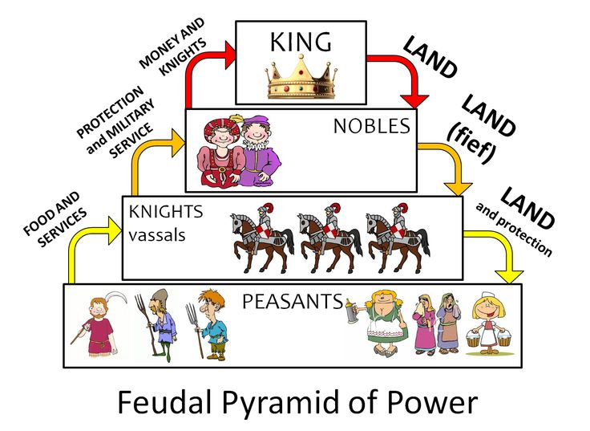
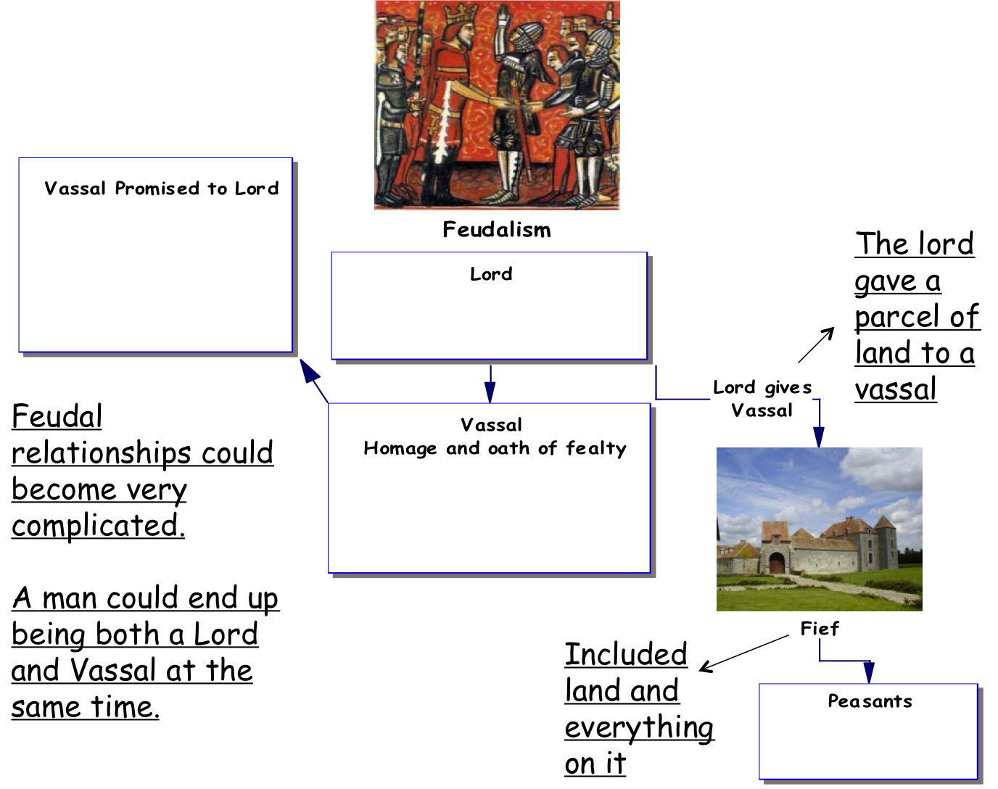
Fealty: feudal tenant's or vassal's sworn loyalty to a lord

Lord/Vassal Relationship
A Lord gave land to a Vassal. This land was called a Fief
The Vassal Promised:

- Loyalty
- Military Service
- Advice
- Collection of Taxes (Rent)
- (Your Lord became your
- Landlord)

Feudal Contract
- The Feudal contract was the agreement that a vassal made with his lord.
- The Fief: Was land that was given to the vassal by the lord.
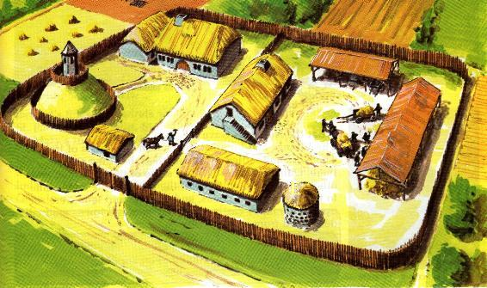
The Manorial system
- A Manor was a self-sufficient agricultural estate run by a lord and worked by peasants and serfs.

- The manorial system was the most convenient device for organizing the estates
of the aristocracy and the clergy in the Middle and it made feudalism possible.

- The typical western European manor in the 13th century consisted partly of the cottages, huts, and barns and gardens of its peasants, which were usually clustered together to form a small village.
  - There might also be a church, a mill, and a wine or oil press in the village. Close by was manor house, of the lord, which might be inhabited by him or merely by his steward if the lord happened to hold more than one manor.
  - The village was surrounded by arable land that was divided into three large fields that were farmed in rotation, with one allowed to lie fallow each year. There were also usually meadows for supplying hay, pastures for livestock, pools and streams for fishing, and forests and waste lands for wood gathering and foraging.

Serfdom
- Many peasants at this time became serfs. A serf was a peasant who was bound to the land and didn’t really own any land of their own.
As the population of Europe increased during this time there was less land to go around. Many peasants lost their holdings and became serfs.
Serfs could not leave the manor, they had to work to pay rent, and had to pay fines and fees for various services on the manor. Serfs also could not marry without the Lord’s permission.
- In exchange for their labor, the lords of the Manors did owe the serfs protection in the event of invasion.
- They also were able to keep a percentage of the crops they produced on the manor for their own families.

The Daily Life of Peasants
- Peasants lived a hard-working simple life.
- They lived in houses which had thatched roofs resting on timber framework with the spaces filled with mud and straw. There were few, if any windows.
- Many houses only had one to two rooms, there was little privacy.
- Often their animals slept inside the house with serfs to provide warmth

