World History – Fall Final

Describe the transition from Paleolithic to the Neolithic Era.

List three effects of the domestication of plants and animals

1.
2.
3.

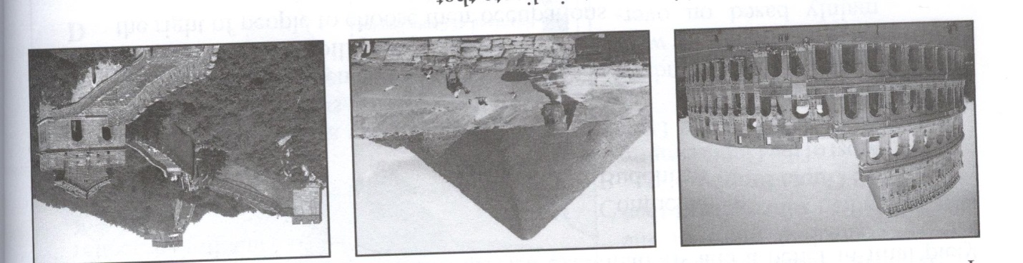
What general statement can be made based on the pictures?

What characteristic marks the beginning of a civilization?

List 3 major characteristics of Christianity?

1.
2.
3.

How did the Jewish view of God differ from the beliefs of most people in the ancient world?

List and describe the 5 Pillars of Islam

1.
2.
3.
4.
5.

List and describe the 5 K’s of Sikhism
1.
2.
3.
4.
5.

Describe Buddhism and its characteristics

List two similarities between Buddhism and Hinduism

1.
2.

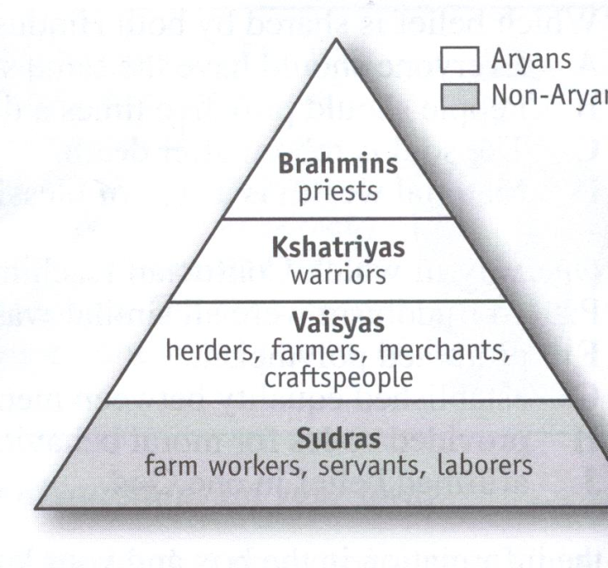

What concept is illustrated in the diagram

How can a Hindu “move up” in the caste system?

What was brought to India by the Aryans?

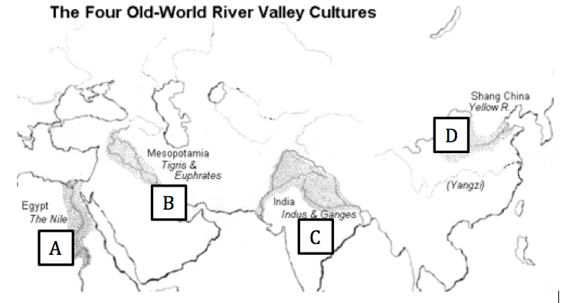

An archaeologist discovered a preserved mummy, hieroglyphics written on stone walls, and an embalmed pharaoh.

In which location on the map was this site most likely found?

Describe cultural diffusion and what helped spread cultures in ancient civilizations.

The river valleys of the Tigris-Euphrates, the Nile, the Indus, and the Yellow River were centers of civilization because they:

Explain how the Babylonian Code of Hammurabi and the Roman Twelve Tables similar?

“If a seignior (noble) has knocked out the tooth of a seignior of his own rank, he shall knock out his tooth. But if he knocked out a commoner’s tooth, he shall pay one-third mina of silver.
--Code of Hammurabi
Which principle of Babylonian society does this excerpt from the Code of Hammurabi illustrate?

The Code of Hammurabi was a major contribution to the development of civilization because it:

Describe 2 accomplishments associated with the Gupta Empire

1.
2.

What Indian Emperor lead to the spread of Buddhism and peace in India?

How can one see that the Indus Valley civilization had a centralized government?

The Aryans divided people into classes by:

The Mandate of Heaven is the idea behind which Chinese philosophy?

What was one similarity between the ancient civilizations of Egypt and China?

What religions were practiced in Ancient China?

1.

2.

3.

A religious example of “cultural diffusion” in early Chinese history was:

Describe the form of government that lead the Shang Dynasty.

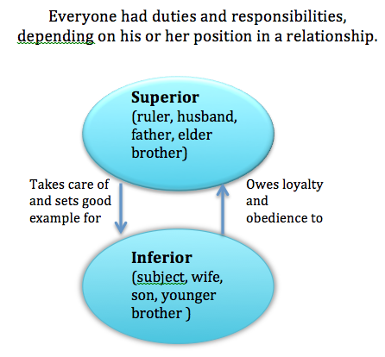

What Ancient Chinese philosophy is defined by the chart above?

Confucius taught the Chinese people that their most important duty was

Describe Legalism

Describe the silk road

List 2 differences between classical civilizations and river valley civilizations.
1.
2.

What characteristic did the Persian Empire share with the Roman and Incan Empires?

Greece geography created what type of civilizations?

Describe the causes of the Persian War.

List 3 characteristics of Sparta and Athens
Athens
1.
2.
3.

Sparta
1.
2.
3.

What resulted from the Peloponnesian leagues victory of the Peloponnesian Wars?

In Athens, during the Age of Pericles, every male citizen

We regard an individual that takes no interest in public affairs not as harmless but as useless. Pericles

The quotation above illustrates the importance ancient Athenians placed on individual participation in the:

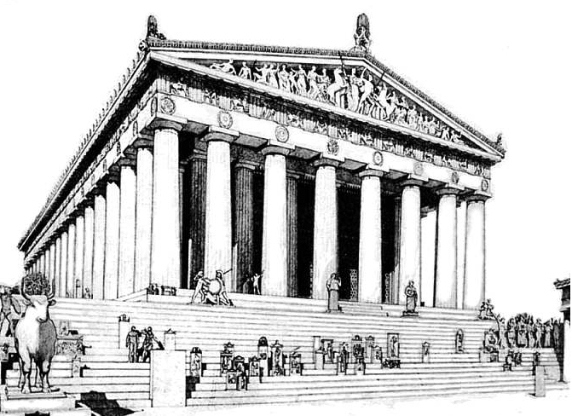
Which culture created marble temples such as the Parthenon (pictured above) with ideal proportions and the first works of drama and history?

List 3 characteristics of the Golden Age of Greece.
1.
2.
3.

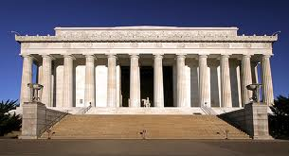

The following is a picture of the Lincoln Memorial. It was influenced by what piece of Greek architecture?

List the three government forms in order described in the passage by Aristotle.
1.
2.
3.

Which society was the first to practice direct democracy?

Define direct democracy and indirect democracy.
Direct-
Indirect-

Describe the different between Athenian democracy and modern United States democracy.

Define:

--Monarchy

--Aristocracy

Alexander the Great’s most lasting achievement was

What was the new culture spread by Alexander the great?

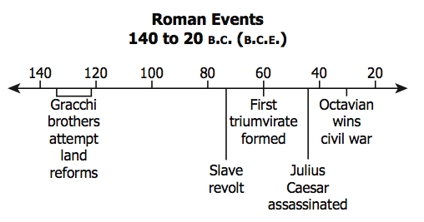

The main effect of the events on this timeline was the:

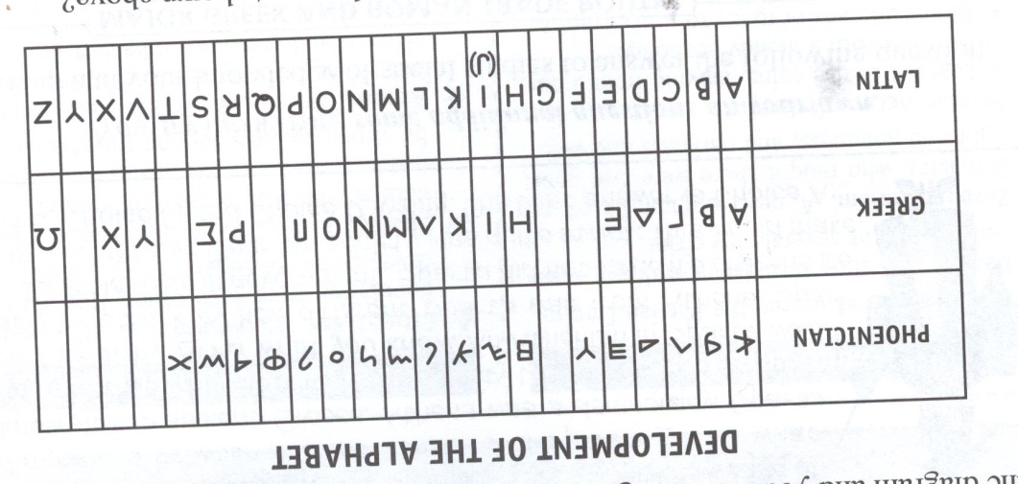

What conclusion can be best drawn from the chart above about the spread of culture?
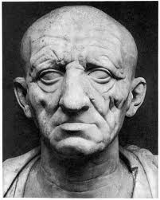

The following would be an example of Roman art and their emphasis on preciseness or exactness. This type of art is known as:

Describe Ancient Rome’s justice and legal system.
Justice-

Legal-

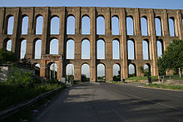

The accomplishment of Roman engineering shown in the picture above is an example of:

Babylonian had Hammurabi’s Code as its written form of law; What written form of law did the Roman’s follow?

How were the collapses of the Roman Empire and the Han Dynasty similar?

The Han Dynasty and the Roman Empire were similar in that both:

Which statement is most accurate based on the information in the map?

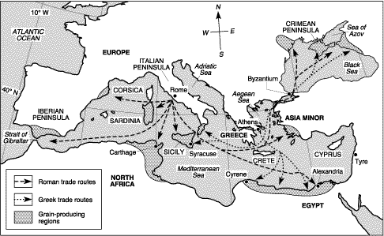

The map supports the theory that the Roman Empire united the Mediterranean region under its control because:

Explain how Constantinople became the center of the Byzantine Empire?

In Western Europe, what resulted from the Western Roman Empire was invaded and collapsed?

List 4 causes of the “fall” of Rome.

1.

2.

3.

4.

List 3 results of the “fall” of Rome.
1.
2.
3.

After the fall of Rome, the eastern portion of the Roman Empire became known as the

“Western Europe went into a long, deep sleep. Learning was found only in the religious orders. Fear and chaos reigned.” What period in history does this statement by a historian best describe?

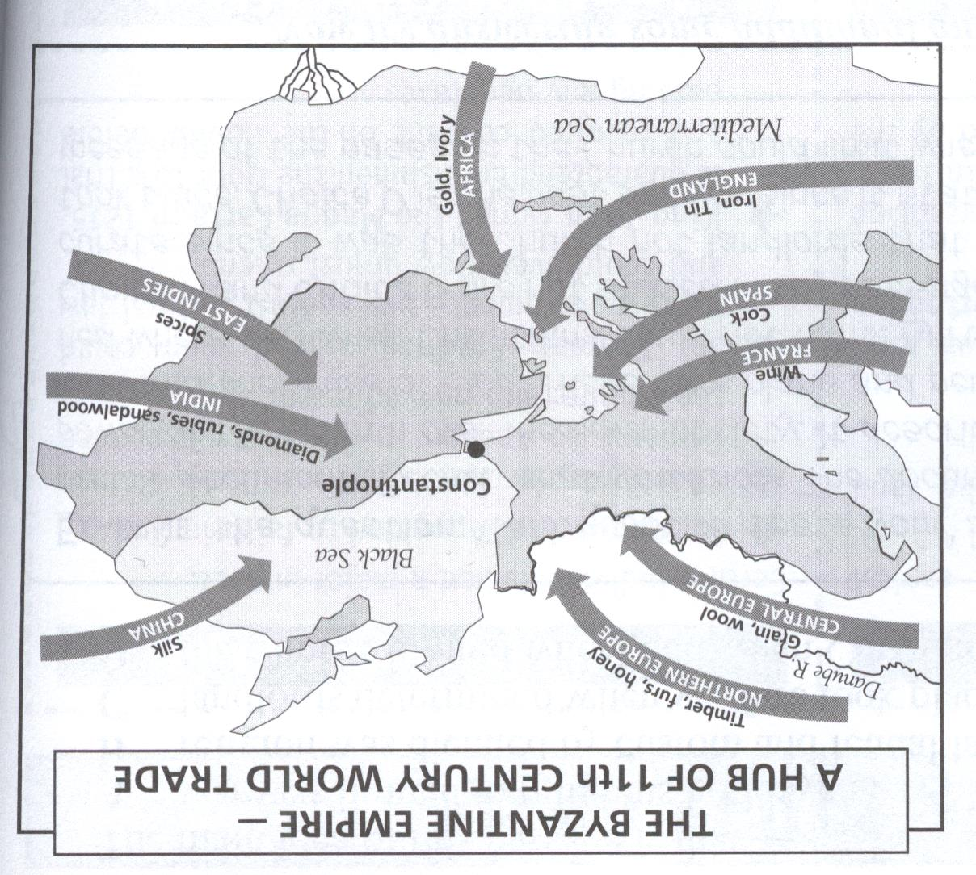

Based on the information provided in this map,
describe Constantinople’s role in trade throughout Europe.

What was the Magna Carta? What role did it have on the power of the king?

Describe the role of the Roman Catholic Church in Western Europe during the Middle Ages.

What did the caste system in India and the feudal system in Europe have in common?

Describe feudalism and the role of the lords, vassals, and peasants.

Feudalism-

Lord-

Vassal-

Peasants-

“The Peace of God declared that feudal warfare could not take place on church property, and it promised sanctuary in churches and abbeys to fugitives from combat. The Truce of God forbade fighting from Wednesday evening until Monday morning, on holidays, and during the religious seasons of Christmas and Lent.”

The main idea of this passage is that:

A major goal of the Catholic Church during the Crusades (1096-1291) was to:

List 3 effects of the Crusades
1.
2.
3.

“…For many in the contemporary Arab world, the Crusades are viewed as having begun nearly a millennium of conflict with what would become the West. The Crusades are seen as representing the constant threat of Western encroachment [aggression]. But many scholars say that is an inaccurate view of the Crusades.
--Mike Shuster, reporter
“The Medieval Crusades were taken [by some modern writers] and turned into something that they never really were in the first place. They were turned into an attempt to bring the fruits of European civilization to the Middle East, when, in fact, during the Middle Ages the great sophisticated and wealthy power was the Muslim world.”
--Thomas Madden, St. Louis Univ.
History of Relations between the West and Middle East

These statements indicate that the history of the Crusades:

The Crusades have been called one of "history's most successful failures."
List 2 reasons for the statement

1.
2.

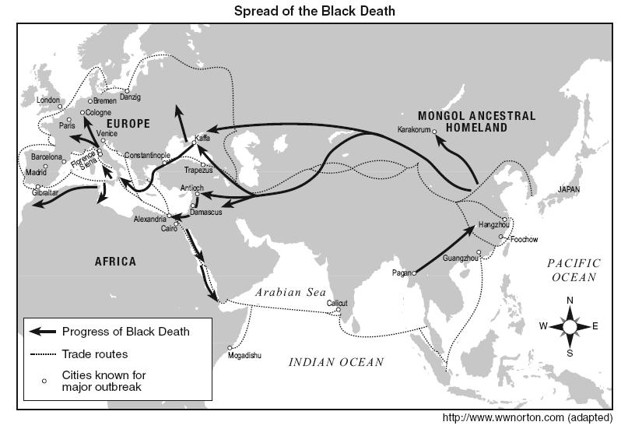

List 3 effects of the Bubonic Plague
1.

2.

3.

The information on the map suggests that the Black Death spread to Europe as a result of contact with:

One characteristic of the “Golden Age” of Muslim culture was the:

The Golden Age of Muslim culture was best known for its

“The lord of this Mali kingdom has a great balcony in his palace. There he has a great seat of ebony that is like a throne fit for a large and tall person. It is flanked by elephants’ tusks. The king’s [weapons] stand near him. They are all gold; sword and lance, bow and quiver of arrows. Before him stand about twenty Turkish pages, who were brought from Cairo. One of these standing on his left, holds a silk umbrella topped by a dome with a hawk made of gold. The king’s officers are seated in a circle near him, in two rows, one to the right and one to the left. Beyond them sit the commanders of the cavalry. In front of him there is a person who never leaves him and who is his executioner; and another who is his official spokesman. In front of him there are also drummers. Others dance before their king to make him merry.
--Ibn Battuta, 1349

Which statement best expresses Ibn Battuta’s point of view in this passage?

List 3 reasons for the success of ancient kingdoms in Western Africa.

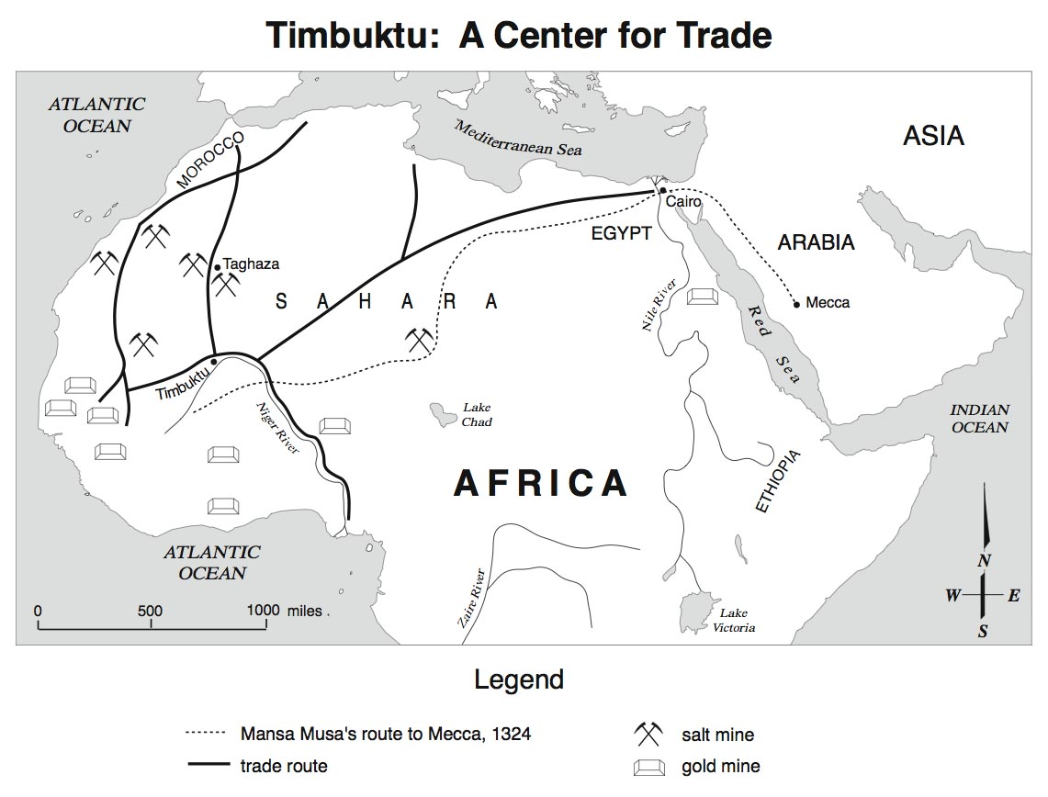

89. Based on the map, which goods were traded in Timbuktu?

Based on the map, which conclusion can best be drawn about this region?
“As for the spread of Islam, it was probably checked less by the mosquito than by the tsetse fly. The Arabs were desert people who had succeeded in taming the camel and the horse and had used these animals partly for the expansion of Islam elsewhere. The fact that North Africa had so much desert aided the initial Arab penetrations. The desert was familiar to the new conquerors. But thickness of vegetation growth as well as the presence of the tsetse fly in some areas kept the camels and the horses at bay and checked the advance of Islam in at least certain parts of Sub-Saharan Africa.”

--Professor Ali Mazuri, The Africans, 1986

List 3 ways that the Silk Road and the West African trade routes were similar.
1.
2.
3.

With which statement would the author of this passage most likely agree?

How were the African kingdoms of Ghana, Mali, and Songhai similar?

The Aztec calendar and the Maya use of zero both illustrate that pre-Columbian cultures in the Americas:

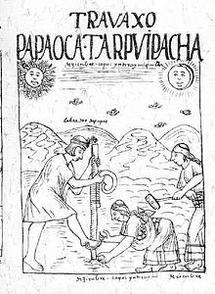

Describe the agricultural systems of the Mesoamerican tribes.

What does the above drawing illustrate about pre-Columbian Inca civilization?

Describe the Incan civilization.

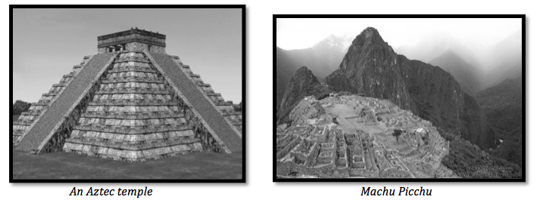
What do these two structures suggest about ancient pre-Columbian civilizations?

