**European Exploration Notes**

**The biggest reasons for the Age of Exploration: “The 3G Theory”**

1. Desire for spices, and the profit from selling and trading them. Expanding economies and increased trade in Asia, led to the need for new raw materials. _____________
2. Competition between European powers. The Desire to be first to explore

new places for their country _______________

1. To diffuse (spread) Christianity _____________

**The search for spices**

* During the Middle Ages, the Crusaders who fought the Muslims in the

Middle East learned of **_____________,**  and brought them back to Europe.

* The Europeans wanted cinnamon, cloves, nutmeg, and most of all pepper to spice and preserve meat, make perfume(s).
* The chief source of spices was the Moluccas (in modern day **______________**), which they called the **_________________________.**

**The Muslim Control on Trade**

* Following the fall of **_____________________**(it became Istanbul), Europe no longer had their “gateway to the East.”
  + Trading over land was expensive and dangerous.
* **________________________________** sailors controlled the trade by sea.
* Other European sailing powers (Spain and Portugal) wanted in on the riches of the spice trade, but had to find a way to get there.

**Improved technology leads to better sailing techniques…**

* European **________________________**(mapmakers) created much better maps and charts of the sea and its currents.
* Europeans mastered the use of the**___________________**, an instrument developed by the Greeks and mastered by the Muslims, to determine their latitude at sea.
* The **______________,** a ship that combined European body styles with Muslim triangular sails and Chinese rudders, made ships much faster and able to travel farther.

**Portugal**

* By the 1400s, Portugal was strong enough to expand into Muslim controlled North Africa.

**Henry the Navigator**

* Prince Henry, known as “**Henry the ____________________**,”
  + hoped to spread Christianity and find Muslim gold
  + began a school for cartographers, sailors and captains at Sagres.

**Bartolommeo Diaz**

* In 1487, Bartolomeu Diaz, rounded the southern tip of **_____________**. He ended the myth that the sea was full of monsters, and it gave hope to those who wished to sail to India. He named the tip of Africa the “**_______________________________”**

**Vasco da Gama**

* In 1497, **__________________________** led four ships around the southern tip of Africa, and on his next voyage, made it to the port of Calicut, in western India.
* The spices he brought back sold at **_______________** of the money he put into it.
* His sailors paid a heavy price, they discovered **____________**, a disease caused by lack of vitamin C.

**Spain**

**Christopher Columbus**

* An Italian sailor from Genoa wished to sail for Portugal. He had an idea that since the world was round, a relatively new concept at the time, that if he sailed westward, that he would reach India faster. His name was **_________________________________**.
* Portugal refused to sponsor him, so he got help from the Spanish King Ferdinand and his wife Isabella, who were famous for expelling the Muslim Moors from Spain.
* Columbus made two huge errors:
  + Underestimating the size of the world greatly
  + Not knowing that two continents lay in his way
* He had three ships… ________________________________________. He sailed west and ran into the islands of the Caribbean. Since he thought he was in the Indies, he called the people he found there “Indians.”

**Columbian Exchange**

* Massive **exchange of ___________________________________________**.
* These things moved **_____________________________________**
* Started with Columbus.
  + To the Americas: cows, horses, wheat, smallpox, plus much more.
  + To Europe: potatoes, tomatoes, tobacco, corn, plus much more.
* In 1507 a German cartographer read reports of a “new world” written by an Italian sailor named **_____________________________**.
  + He labeled the region “America” after Vespucci. The region that Columbus had found became known as the **_____________________.**

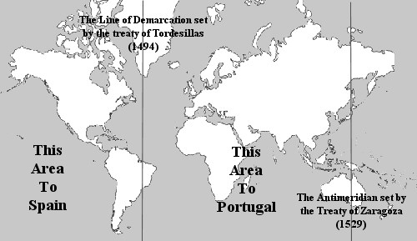**Line of Demarcation/**

**Treaty of Tordesillas**

* **___________________________** fought over who got what in the Americas
  + finally Pope Alexander VI stepped in and ordered both Catholic monarchs to settle the problem.
* On June 7, [1494], the Spanish and the Portuguese signed a treaty to divide the world in two.
  + The dividing line ran through the Atlantic with **Spain gaining lands to the____________**including all the Americas.
  + **______________ was granted to Portugal**. The eastern half including Africa and India was given to Portugal.

**Circumnavigating the Globe**

* In 1519, a minor Portuguese noble named **___________________________** set out from Spain with five ships and hundreds of men.
* He discovered the Strait of Magellan, and sailed into the _______________ –he named it because it means “peaceful”- Ocean.
* He faced several mutinies, and was murdered in the Philippines.
* In1522, one ship and 18 sailors returned to Spain, and were credited with being the first to sail all the way around the globe, or

**_______________________** it

**Spanish conquest of the Americas**

**Cortez**

* In 1520, **__________________________** (also spelled Cortes) and his

**_______________________** went to the “new world” in search of gold. They found the Aztec Empire in what is today Mexico.

* With the use of **___________**, and with the help of the fact that the Aztecs

had no immunity to the diseases **____________________** the Spaniards carried, the Aztec Empire was almost completely eliminated.

**PIzarro**

* Soon after Cortez, **_________________________** followed. He went to

South America to what is now Peru. He destroyed the **___________**culture for their gold.

Pizarro destroys the **______________________**

* Spain sent ships back and forth to the new world to take the gold home and make themselves the richest nation in the world. These ships came to be

known as the **_____________________________.**

**Encomienda System**

* A **____________________________**

emerged with the Indians and slaves at the bottom, the mestizos and mulattos in the middle and the Europeans and their descendants at the top.

* + 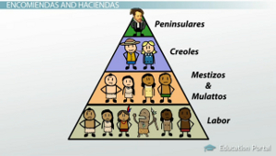Royal protection of the Indian was generally ineffective. Because Spaniards and creoles looked down on manual labor, they developed several labor systems to force **Indians to work for Spanish landowners.**

**What was the Triangular Trade?**

* 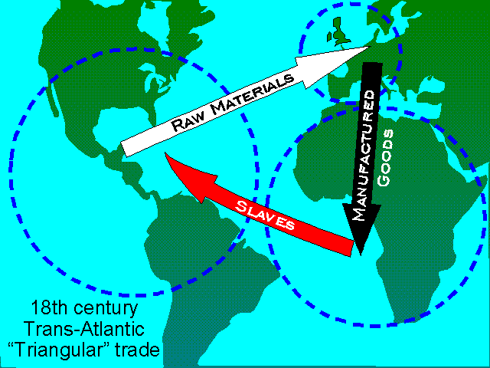System of trade between Europe, Africa, and the Americas.
* Stage 1: **____________________** to Europe (tobacco, rum, sugar)
* Stage 2: **____________________________**  to Africa (guns, cloth, rum)
* Stage 3: **_____________** to the Americas to make raw materials.

**The English, Dutch, and French in the “New World”**

* The Northern European countries spread **_____________________** to the “New World.”
* England sent protestants looking for religious freedom to what is now the U.S.
* France settled in the areas founded by Cartier, most notably, Quebec.
  + Had the best relationship with the Native Americans
* Like the Spanish **______________________** system who used the slave labor of the Aztec and Mestizo people, the Northern Europeans wished to

plant **______________________** which required lots of labor.

* + Europeans began __________________systems in the Caribbean and the Americas which destroyed the economies of the people who first lived there, as well as the environment
  + **___________________________________** (slavery was based on race).
  + Both systems leave behind a rigid class system that lasts for generations.

**Trade in Africa**

* Made possible by outposts established along the coast.
* Slave ports.
* Trade in slaves, gold, and other products with peoples of the interior.
* Better source of labor because they were **__________________** to European disease

**Trade in Asia**

* **_______________________**was done by small groups of merchants who obtained the rights from the monarch.

**________________________________________** trading companies invest heavily in trade in the east.

Dutch East India Company

**____________________________-**

* pooling of $$ by investors with the hope of making a profit (Dutch East India Company, British East India Company)

**Commercial Revolution**

* Opening links to Asia, Africa, and the Americas had far rising consequences for Europe, most imply the rise of:

**_______________________-**

privately owned and operated business with one goal…..make a **______________!**

* Commercial Revolution
  + Spurred _________________overseas
  + Promoted new business methods
  + Increased**_________________** amongst European nations
  + European global **___________________**
* This led to the birth of a **_________________________** where investment, production, distribution are all determined by

**____________________________________**

**Mercantilism**

* + Economic system based on the government promoting the states’ economy

to improve tax revenues and **________________________________** to prevent profits from going to outsiders

* + Export more than import
  + Governments’ **__________________** was based on gold and silver
  + The colonies were required to provide raw materials to countries and to

purchase **______________________________**

**Impacts of the Commercial Revolution**

* European influence spread to the Western Hemisphere
* End of regional isolation
* Period of European global domination
* Food, animals, ideas and disease to “New World”