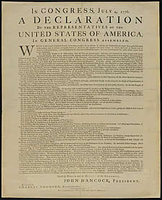
Declaration of Independence

Video: It is too late to _____________________

Historical Context: Thomas Jefferson
- Born to a wealthy Virginia family
- Served in the Virginia ________________
- Selected by the committee of 5 to prepare the draft ____________

- Jefferson’s Viewpoints

  - Jefferson believed in _________________________

  - Jefferson believed the colonies had the right to ______________________________

Main points of the Declaration of Independence
- All men are ______________________________

- Men are given by God ______________________________________________
- We have the _________________________ by God to declare our independence from England
- Governments derive their authority from the consent of the ___________________
- When a government abuses it’s power, the people ______________________________
- ______________________ tried repeatedly to compromise with King George, but was a tyrant
Significance
- American Colonies declare their independence from _______________
- First step in the creation of a new nation.

