India – Indus Valley Civilization

Subcontinent- a large, relatively self-contained landmass forming a subdivision of a continent; the subcontinent of India

Vedic Age (1500 BC to 500 BC) - was the period in Indian history during which the Vedas, the oldest scriptures of Hinduism, were composed. During the early part of the Vedic period, the Indo-Aryans settled into northern India, bringing with them their specific religious traditions.

Caste System - a process of placing people in occupational groups. It has pervaded several aspects of Indian society for centuries. Rooted in religion and based on a division of labor, the caste system, among other things, dictates the type of occupations a person can pursue and the social interactions that she may have. Castes are an aspect of Hindu religion.
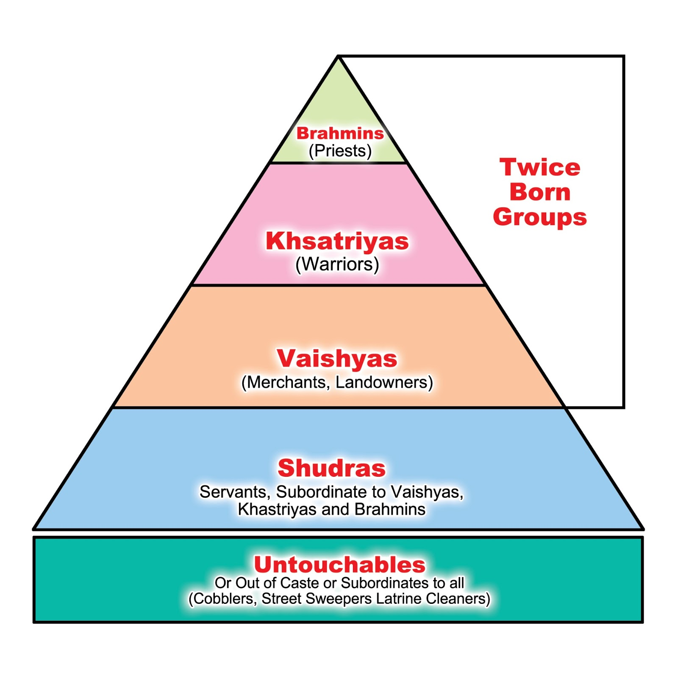
Brahmins - a member of the highest priestly caste or varna in Hinduism.

Kshatriyas - a member of the Hindu royal and warrior class above the Vaisyas and below the Brahmans

Vaisyas - A member of the second-lowest caste, comprising farmers, herders, merchants, and businessmen

Sudras - are people next to the bottom caste system; most are menial workers

Outcastes/Untouchables - a category so demeaned in status that they are considered to be so polluted that they are regarded as outside the caste system entirely

Hinduism –the world's oldest extant religion, with a billion followers, which makes it the world's 3rd largest religion. It is characterized by the belief in reincarnation, one absolute being of multiple manifestations, the law of cause and effect, and the desire for liberation from the cycle of births and deaths.

Polytheism – belief in many gods

Mauryan Empire - (321 BC to 185 BC) a geographically extensive Iron Age historical power in ancient India,

Chandragupta Maurya - the founder of the Maurya Empire and the first emperor to unify most of Greater India into one state. He ruled from 322 BC until his voluntary retirement and abdication in favor of his son Bindusara in 298 BC

Bureaucracy - a system of government in which most of the important decisions are made by state officials rather than by elected representatives.

Asoka – a great ancient Indian ruler, grandson of Chandragupta Maurya—Asoka helped expand the empire and made Buddhism an official religion in India

Gupta Dynasty (320 AD to 550 AD) - The Gupta Empire was an ancient Indian empire, founded by Maharaja Sri Gupta, which existed at its zenith from approximately 320 to 550 CE and covered much of the Indian Subcontinent.

Stupas - a mound-like or hemispherical structure containing “relics", typically the remains of Buddhist monks or nuns, used as a place of meditation.

Patriarchal - characteristic of a system of society or government controlled by men.

Dowry - property or money brought by a bride to her husband on their marriage

China

Confucius - a Chinese teacher, editor, politician, and philosopher

Five Relationships (of Confucianism) - (1) ruler and subject; (2) father and son; (3) elder brother and younger brother; (4) husband and wife; and (5) friend and friend. All, except the last, involve the authority of one person over another.

Legalism - the act of putting law above gospel by establishing requirements for salvation

Daoism - a philosophical, ethical or religious tradition of Chinese origin that emphasizes living in harmony with nature

Yin and yang - (in Chinese philosophy and religion) two principles, one negative, dark, and feminine(yin) and one positive, bright, and masculine (yang) whose interaction influences the destinies of creatures and things.

Qin Dynasty (221 BC to 206 BC)

The Great Wall - A stone wall extending for fifteen hundred miles across northern China. Built to defend the Chinese border in ancient times, it has become a favorite destination for visitors to the country.

Terra Cotta Soldiers - hundreds of detailed life-size soldier and horse models of Qin Shi Huangdi the First Emperor of China, which represent the army that triumphed over all other Chinese armies in the Warring States Period

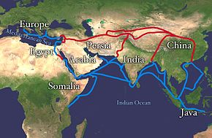
Han Dynasty (206 BC to 220 AD)

Silk Road - an ancient network of trade and cultural transmission routes which were central to cultural interaction through regions of the Asian continent connecting the West and East.

Civil Service Examinations – a system or method of appointing government employees on the basis of competitive examinations, rather than by political patronage.

