Causes of WWI
M – Militarism
A – Alliances
I – Imperialism
N – Nationalism
- Nationalism
- Imperialism
- The Alliance System
- Militarism

- The Assassination of Archduke

Nationalism
- Nationalism means being a strong supporter of the _______________________ of one’s own country.
  - This can be good and bad.

Italy and Germany
- During the _____________________________ (the meeting to put Europe back together after Napoleon was put into exile), the countries of Britain, Austria, Prussia and Russia created a new Europe that left

_______________________________ divided and basically getting the raw end of the deal.
  - Strong nationalist movements led to the _________________of Italy (1861) and Germany (1871)

France
- France lost land to Germany at the end of the ___________________________, which left nationalist groups in France dead-set on getting that land back.

Austria Hungary &______________
- There were opposing nationalist groups within these countries and each one wanted their own land and government.

Imperialism

- Imperialism is when a country ___________________________ or countries and then subjects the people to its rule.

  - The rise of __________________ meant that countries needed new markets to get resources from and sell their goods.
- Britain, France, and Germany had __________________________________ with each other over who ruled the lands in Africa. They quickly tried to claim the land for themselves (this is known as the Scramble for Africa)

Alliances

- An alliance is an ____________________________between two or more countries to give each other help (financially, militarily, and through goods and services) when they need it.
  - When an alliance is signed, those countries become known as _________

- There were many alliances made between the years 1879 and 1914
  - These alliances were important to causing WWI because they meant that many countries had no choice but to declare war if one of their allies did first.

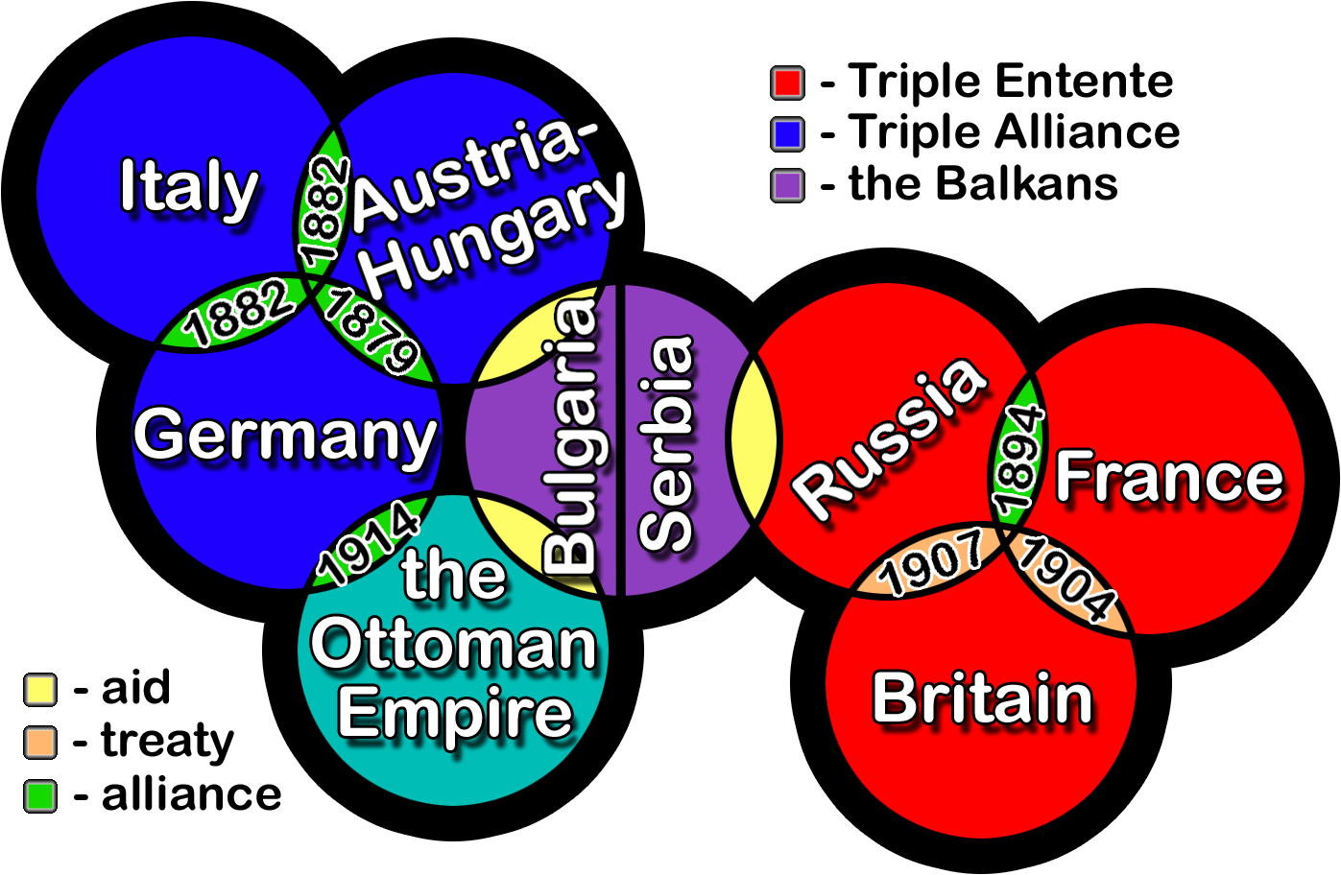

Militarism

- Militarism is when a country or government places high importance on military forces.
- Building many _______________

- Enlisting many _______________

- Tensions that were growing in Europe led to an __________________ (building more weapons than the enemy)

- French and German armies _______________ between 1870 and 1914

- Britain and Germany were _______________with each other for who controlled the seas (invention of battleships)
- Countries began laying out war plans and maps of where to attack.

Assassination

- The ____________________________ of WWI was the assassination of Austrian archduke Franz Ferdinand and his wife on June 28th, 1914.
  - Ferdinand was the heir to the Austria-Hungarian throne.

  - He and his wife were murdered in Sarajevo, Bosnia by a Serbian Nationalist, Gavrilo Princip, who worked for an organization known

as the ______________________________.

- Immediately following the assassination _______________________________ to Austria-Hungary and pressured them to declare war on Serbia.
  - France strengthened its backing of Russia.
  - Austria-Hungary was convinced that the Serbian government was behind

the assassination and issued Serbia an __________________________, and Serbia agreed almost entirely.

The Domino Effect

- Austria-Hungary still wasn’t satisfied, and __________________________ on Serbia on July 28, _______________
  - Russia, in support of their Ally Serbia, declares war on Austria-Hungary
  - Germany declares war on Russia, and two days later on France.
  - Germany’s invasion of Belgium (who declared it was neutral) to attack

France, leads _____________________________________________.
  - Thus, WWI had begun.

