CH 17: European Exploration

3G Theory- God, Glory, Gold. Theories used to justify the Expansion of Europe to Western Worlds.

Cartographer- Map Maker

astrolabe- Calculated the time and the position of the Sun and stars in the sky

caravel- a small, highly maneuverable sailing ship developed in the 15th century by the Portuguese to explore along the West African coast and into the Atlantic Ocean

scurvy- Lack of Vitamin C causing general weakness, anemia, gum disease, and skin hemorrhages

circumnavigate- sail all the way around (something, especially the world).
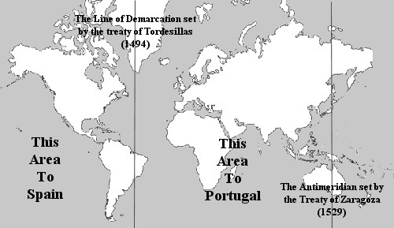

Line of Demarcation-
Agreement between Spain and Portugal dividing control of Western hemisphere.

Chinese response to westerners-
China Isolated themselves refusing to open their economy to the West.

conquistador- Term given to Spanish and Portuguese conquerors of the western world.

plantation- large piece of land where one crop is specifically planted for widespread commercial sale and usually tended by resident laborers.
Encomienda system-
created by the Spanish to control and regulate American Indian labor and behavior during the colonization of the Americas.
missionary- a person sent on a religious expedition to convert local inhabitants.

revenue- income that a business has from the sale of goods and services to customers
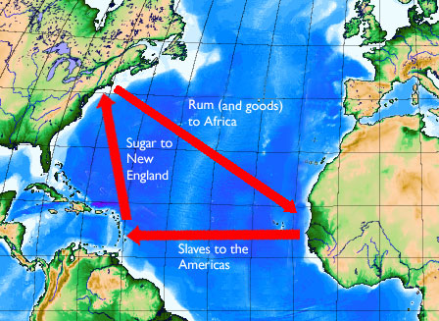
triangle trade route-
a pattern of colonial commerce in which slaves were bought on the African Gold Coast with New England rum and then traded in the West Indies for sugar or molasses, which was brought back to New England to be manufactured into rum.
repeal- revoke or annul a law of governmental act.

monopoly- One company is the sole provider of a particular good or service

inflation- sustained increase in the general level of prices for goods and services.

entrepreneur- a person who organizes and operates a business or multiple businesses

joint stock company-
a business where different stocks can be bought and owned by shareholders
mercantilism- a system in which a country attempts to amass wealth through trade with other countries, focus on export rather than import.
tariff- a tax on imports or exports

Columbian exchange-
a period of cultural and biological exchanges between the New and Old Worlds. Exchanges of plants, animals, diseases and technology transformed European and Native American ways of life.
Commercial Revolution –
a period of European economic expansion, colonialism, and mercantilism which lasted from approximately the late 13th century until the early 18th century. It was succeeded in the mid-18th century by the Industrial Revolution

CH 18: Absolutism

Absolute Monarch- form of government in which the ruler has unrestricted political power among his or her people
Divine Right - a political and religious doctrine of royal and political legitimacy. It asserts that a monarch is subject to no earthly authority, deriving the right to rule directly from the will of God.

Spain

Charles V- (ruled from 1506 – 1556) King of Spain, brother of Queen Isabella, and father of Philip II

Philip II- (ruled from 1554 – 1598) King of Spain during the height of its influence and power, supported the Catholic Counter Reformation and sent the Spanish Armada to invade England

France

Huguenots- French Protestants, who, due to religious persecution, were forced to flee France to other countries in the sixteenth and seventeenth centuries.

Henry IV- (ruled from 1589 – 1610) Henry IV granted religious freedom to Protestants by issuing the Edict of Nantes during his reign as king.

Edict of Nantes- granted the Calvinist Protestants of France (also known as Huguenots) substantial rights in the nation, which was, at the time, still considered essentially Catholic.

Louis XIV- (ruled from 1643 – 1715) the Sun King, ruled France for 72 years, longer than that of any other known European sovereign

Versailles- Extravagant Palace and principal residence of the French kings from the time of Louis XIV to Louis XVI.

England

Elizabeth I- the long-ruling queen of England, governing with relative stability and prosperity for 44 years. Seen as the main enemy of Catholic Spain.

James I- King of Scotland from 1567 who also took English Crown in 1603 until 1625. Successor of Elizabeth I.
Charles I - (ruled from 1625 – 1649) King of England whose disagreements with Parliament got him publically executed.

Petition of Right- English constitutional document from 1628 that sets out specific liberties of the subject that the king is prohibited from infringing.

Cavaliers- wealthier male Royalist supporters of King Charles I and his son Charles II during the English Civil War

Roundheads- supporters of the Parliament of England during the English Civil War

Oliver Cromwell- Leader of the Roundheads during English Civil War

Commonwealth- period in the post-Civil War period (1649 – 1660) when England was ruled without a King.

Charles II - (ruled from 1660 – 1685) son of Charles I, who lived in exile until his restoration to the throne in 1660 marked the end of republican rule in England
James II- (ruled from 1685 until 1688) last Roman Catholic monarch to reign over England, Scotland and Ireland. He was disposed in the Glorious Revolution

Glorious Revolution
was the overthrow of King James II of England (James VII of Scotland and James II of Ireland) by Parliament; “glorious” because a leader was removed from power with no bloodshed.

William and Mary-
asked by Parliament to jointly rule England after the Glorious Revolution of 1688 removed Mary’s father from power

English Bill of Rights-
separation of powers, limits the powers of the king and queen, enhances the democratic election and bolsters freedom of speech.

Habeas Corpus- legal action or writ by means of which detainees can seek relief from unlawful imprisonment.

Limited Monarchy-
form of government in which a king or queen acts as Head of State. The ability to make and pass legislation resides with an elected Parliament, not with the Monarch.

Russia

Peter the Great- Russian Czar known for his extensive reforms in an attempt to establish Russia as a great nation: created a strong navy, reorganized his army according to Western standards, secularized schools, administered greater control over the reactionary Orthodox Church, and introduced new administrative and territorial divisions of the country.

Catherine the Great-
the most renowned and the longest-ruling female leader of Russia who brought Westernization to Russia, expanded the empire, and reorganized the political administration.

