Western Europe (CH 8.4 & 10)

How did the fall of Rome impact Western Europe?

What was the central focus of Germanic customs and social institutions?

What was the main goal of the Vikings?

How did Clovis gain the support of his people?

How did Charlemagne briefly unite much of Western Europe?

What were the achievements of the Carolingian Empire?
-

-
What led to the Downfall of Charlemagne and the Carolingian Empire?

Define fief:
How is that different from a manor?

Who had complete control of the fief?

What was the role of women on the estate?

What is the manorial system?
-
-
What were some new agricultural practices developed in the Middle Ages, and how did they impact society?

What is feudalism?
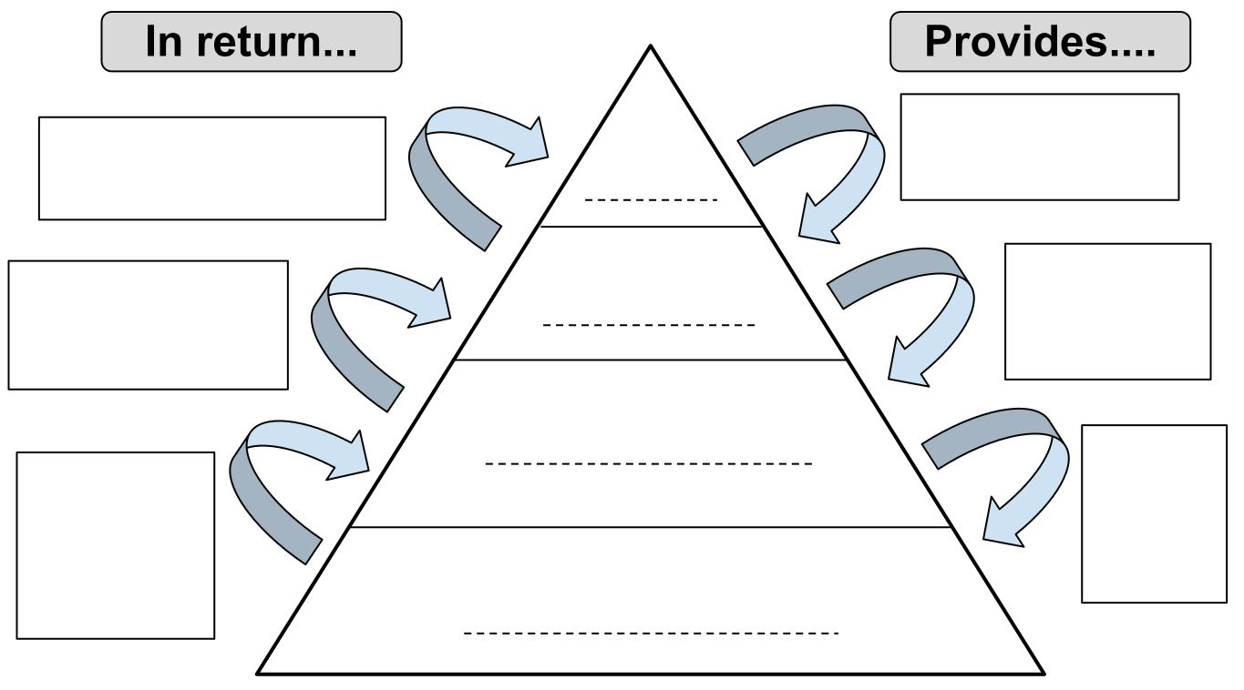

What technological innovations developed in Western Europe during the Middle Ages?

What led to the revival of trade during the 1000’s and 1100’s?

What was the impact of this revival of trade?

What was a result of growth of cities and towns?

Who is responsible for spreading feudalism in Europe after the Battle of Hastings?

What is Common Law, and who initiated its development?

What is the representative body in England’s government?

Why is the Magna Carta an important document?

How did the church shape medieval society?
-

-
List the powers the church had at its height in power.
-

-

Describe the relationships between the monarchs and church.
-
-

Define
Papal supremacy –

lay investiture –

excommunicate -

interdict –

What were 2 instances of power struggles between the church and state?
-

-

What were 2 causes of the Crusades?
-

-

What are the lasting effects of the Crusades?

What led to the Great Schism?

What are 2 characteristics of Medieval architecture?
-

-

What is vernacular language, and what caused the shift to literature being written in the vernacular?

What was the goal of scholasticism?

What led to the spread of the bubonic plague?

Describe the impact of the Black Death on Europe.
-

-

-

